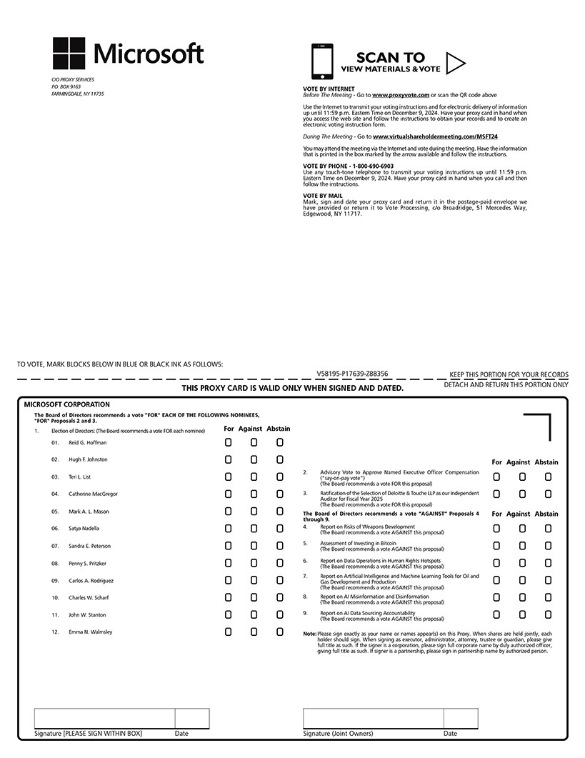

Annual Shareholders Meeting Information:

www yirtual sharehol dermeeti ng com/MSFT24

Date:December 10,2024

Time:8:30AM PT

Important Notice Regarding the Availability of Proxy Materials for the AnnualShareholders Meeting: The Notice and Proxy Statement and Annual Report *are* available at [www.proxyvote.com.](http://www.proxyvote.com/)

VS8196-P17639·Z383S6

MICROSOFT CORPORATION

This Proxy is Solicited on Behalf of the Board of Directors

The undersigned hereby appoints SANDRA E. PETERSON and SATYA NADELLA, and each of them, with full power of substitution, as proxies to vote all the shares the undersigned is entitled to vote at the AnnualShareholders Meet ng of the Company to be held virtually December 10,2024 at 8:30a.m.Pacific Time and at any adjournments thereof. Such shares shall be voted asindicated with respect to the proposals listed on the reverse side hereof andin the discretion of the proxies on such other matters as may properly come before the meet ng or any adjournment thereof in accordance with and asdescribed in the Notice and Proxy Statement of the Annual Shareholders Meeting.

Thisproxy,when properly executed,willbe votedin themanner directedherein.If nosuchdirection ismadeas toanyitem,this proxy will be voted in accordance with the Board of Directors'recommendations.

Continued and to be signed on reverse side